Dear Students!

Your Notifications are available on Neptun by following the steps below:

- Administration Requests
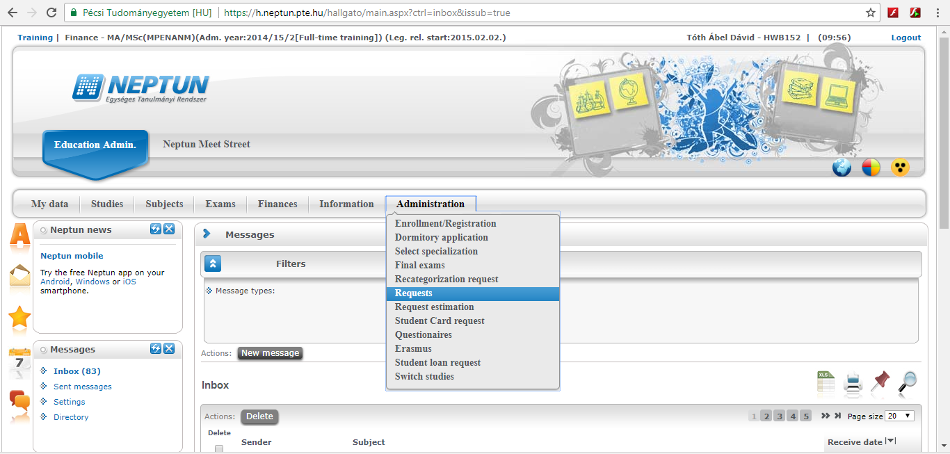
- At the end of ’Kollégiumi jelentkezés’ line, click on the ’+’ sign, then ’View resolution’
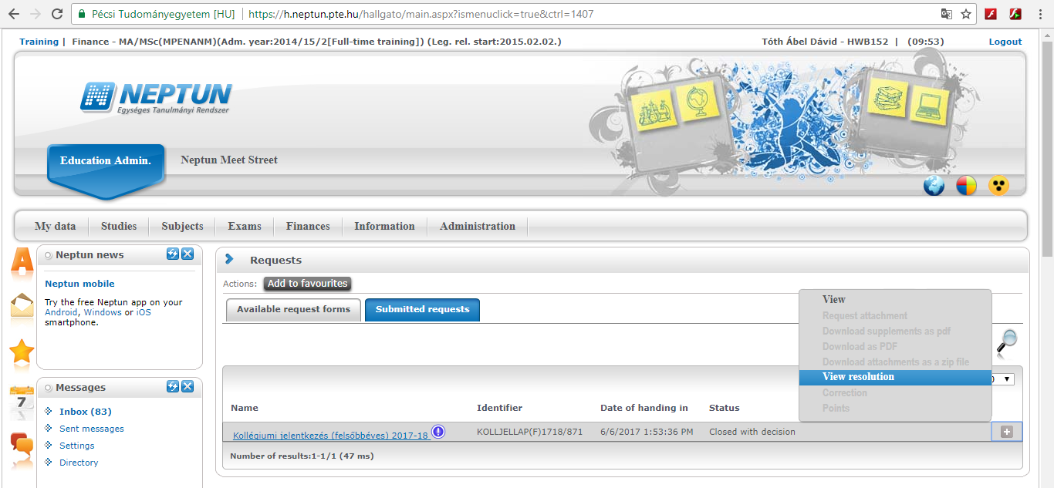
- The download will start and you can read your notification in the PDF file.

